Lesson no 1 Protochordates
The organisms belonging to the Protochordata are generally known as the lower chordates. Protochordates are an informal category of animals (i.e.: not a proper taxonomic group), named mainly for convenience to describe invertebrate animals that are closely related to vertebrates. However, they do form a major division of Chordata. They are also known as Acraniata because they lack a true skull.
Protochordates are members of two deuterostome phyla that are exclusively marine. The Hemichordata, with solitary enteropneusts and colonial pterobranchs, share a ciliated larva with echinoderms and appear to be closely related, but they also have many chordate-like features. The invertebrate chordates are composed of the exclusively solitary cephalochordates and the tunicates with both solitary and colonial forms. The cephalochordates are all free-swimming, but the tunicates include both sessile and free-swimming forms

Characteristics of Protochordata (Tunicates & Amphioxus)
Although the amphioxus and the tunicates are quite different, at one time it was believed that the amphioxus was a descendant of the tunicate larva. Recent genome analysis has called that view into question, but there are still many articles which consider both genera together.
Like the remaining subphylum of the chordates, the Vertebrata, the protochordates have a hollow dorsal nerve cord, gill slits, and a stiff supporting rod, the notochord, the forerunner of the backbone. The protochordates differ chiefly from the vertebrates in not having a backbone. Recent protochordates are thought to have evolved from the same ancestral stock as that which gave rise to the vertebrates.
On the basis of the notochord present, they are divided into three sub-phyla- Hemichordata, Urochordata and Cephalochordata.

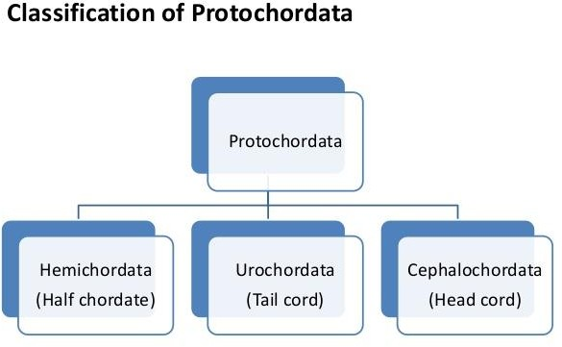

Lesson no 2

Sub-Phylum Hemichordata
Bateson (1885) studied the embryology of some enteropneusts and proposed the name Hemichordata to replace Enteropneusta.
Hemichordate, any of a group of wormlike marine invertebrates closely related to both chordates and echinoderms and usually considered to constitute a phylum, the Hemichordata. The term Hemichordata—from the Greek hemi, meaning “half,” and chorde, meaning “string,” thus, “half- chordate”—was first proposed because the buccal diverticulum, a tubular outgrowth from the mouth cavity forward into the proboscis, or “snout,” resembled a rudimentary notochord—the dorsal, or back-side, supporting axis of the more primitive vertebrates. This theory has since been rejected, however, because it has been determined that the diverticulum bears little resemblance in origin and function to the vertebrate notochord. Molecular studies indicate that hemichordates are more closely related to echinoderms than to chordates. About 90 species have been described.
The phylum Hemichordata includes the acorn worms (class Enteropneusta) and the pterobranchs (class Pterobranchia). Members of both classes live in or on marine sediments. The Hemichordata consist of three classes: Enteropneusta, Pterobranchia, and Planctosphaeroidea. Enteropneusts, or acorn worms (about 70 species), are solitary, wormlike, bilaterally symmetrical animals, often brilliantly coloured. They are known as acorn worms because of the appearance of the proboscis
and collar. Pterobranchs (about 20 species) are minute, colonial, tube-building forms. Planctosphaeroidea are known only from a few floating larvae. Enteropneusts are common in the intertidal zones from the White Sea and Greenland south to New Zealand and the Cape of Good Hope; they are found offshore to depths of 400 metres (about 1,300 feet) or more. They vary in size from a few centimetres long (Saccoglossus pygmaeus of the North Sea) to two metres (about seven feet) or more (Balanoglossus gigas of Brazilian coastal waters).

Hemichordates are distinguished by a tripartite (threefold) division of the body. At the forward end of the body is a preoral lobe, behind this is a collar, and last comes a trunk. The name "hemichordate" means "half chordate," and hemichordates share some (but not all) of the typical chordate characteristics. There are branchial openings, or "gill slits," that open into the pharynx; there is a rudimentary structure in the collar region, the stomochord, that is similar to a notochord; and there is a dorsal nerve cord, in addition to a smaller ventral nerve cord. However, hemichordates are not classified as true chordates, although they are quite closely related. Some DNA-based studies of evolution suggest that hemichordates are actually closer to echinoderms than to true chordates. This is supported by the fact that the larvae of at least some hemichordates look very much like those of some echinoderms.

Of the three classes of hemichordates, the most familiar living ones are the Enteropneusta, the acorn worms. One is pictured at the top right of the page. The triple division of the body is obvious. Acorn worms also have multiple branchial openings, as many as 200 in some species. They are slow burrowers, using the proboscis to burrow through sediment, and may either deposit feed (consume sediment and digest the organic matter, rather like earthworms in soil) or suspension feed (collect suspended particles from the water). Some of these worms may be very large; one species may reach a length of 2.5 meters (almost eight feet), although most are much smaller.

The second living class is the Pterobranchia, an obscure group with only about 20 living species. Pterobranchs as very different from acorn worms; they form colonies in which the individuals are interconnected by stems, or stolons. Individuals, or zooids, are often less than 1 millimeter long. The proboscis is not elongated, as it is in acorn worms, but shield-shaped. The second division of the body bears a pair of branched tentacles that collect small food particles from the water. There
is only one branchial opening. Most strikingly, almost all pterobranch species create and live within a network of tubes, the coenecium. These tubes are made up of the protein collagen, secreted by special glands in the proboscis. Yet similar larvae and a similar tripartite body plan unite the enteropneusts and pterobranchs. This diagram shows a colony of pterobranchs in the genus Rhabdopleura.

What is now considered a third class of hemichordates, the Graptolithina or graptolites, has a checkered history. Graptolites are common fossils in Ordovician and Silurian rocks, but for a long time no one was sure what kind of animals they were. Most fossil graptolites look like nothing so much as tiny sawblades. However, well-preserved graptolites can be seen to be tubular in cross- section, with the "teeth of the saw" formed by short open branches from the main tube. Careful study of the microscopic structure of the tubes of graptolites showed that they are very similar to the tubes of pterobranchs.
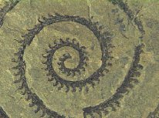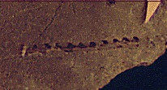

Unlike their pterobranch kin, which typically live encrusting rocks and shells, most graptolites are thought to have been planktonic, floating or slowly sinking through the water. The spiral shape of some was probably an adaptation to slow sinking. Other graptolites may have been connected to gas-filled sacs, keeping them buoyant.

Characteristics of the phylum Hemichordata include:
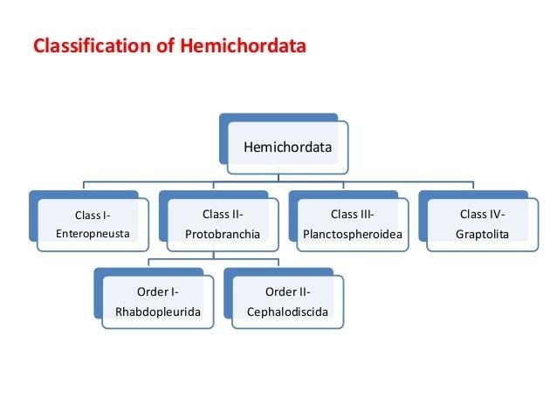
- Marine, deuterostomate animals with a body divided into three regions: proboscis, collar, and trunk; coelom divided into three cavities
- Ciliated pharyngeal slits
- Open circulatory system
- Complete digestive tract
- Dorsal, sometimes tubular, nerve cord

Lesson no 3

Class Enteropneusta
The Class Enteropneusta (acorn-worms) consists of about 75 species of solitary, unsegmented worm-like invertebrates. The body is fleshy, cylindrical and divided into three parts: the muscular contractile proboscis (prosome), the collar (mesosome) and the non-muscular trunk (metasome), each with coelomic compartments. The trunk has many gill slits. Enteropneusts are strictly marine and benthic (either sessile or sedentary). At least one enteropneust species has been reported swarming at the surface of shallow water, feeding on phytoplankton (Brusca and Brusca, 1990) — note that this species, Glandiceps hacksi (Marion, 1885) does not occur in the North Sea.
Members of the class Enteropneusta are marine worms that usually range in size between 10 and 40 cm, although some can be as long as 2 m. Zoologists have described about 70 species, and most occupy U-shaped burrows in sandy and muddy substrates between the limits of high and low tides. The common name of the enteropneusts—acorn worms—is derived from the appearance of the proboscis, which is a short, conical projection at the worm’s anterior end. A ring like collar is posterior to the proboscis, and an elongate trunk is the third division of the body (ﬁgure 1). A ciliated epidermis and gland cells cover acorn worms. A ciliated epidermis and gland cells cover acorn worm. The mouth is located ventrally between the proboscis and the collar. A variable
number of pharyngeal slits are present late ally on the trunk. Their number is from a few to several hundred. Pharyngeal slits are openings between pharynx and the outside of the body.

The mouth is located ventrally between the proboscis and the collar. A variable number of pharyngeal slits, from a few to several hundred, are positioned laterally on the trunk. Pharyngeal slits are openings between the anterior region of the digestive tract, called the pharynx, and the outside of the body.

Lesson no 4
Enteropneusta: Feeding, Digestion and Nervous system
Cilia and mucus assist acorn worms in feeding. Detritus and other particles adhere to the mucus- covered proboscis. Tracts of cilia transport food and mucus posteriorly and ventrally. Ciliary tracts converge near the mouth and form a mucoid string that enters the mouth (Figure 2). Acorn worms may reject some substances trapped in the mucoid string by pulling the proboscis against the collar. Ciliary tracts of the collar and trunk transport rejected material and discard it posteriorly. The digestive tract of enteropneusts is a simple tube. Food is digested as diverticula of the gut, called hepatic sacs, release enzymes. The worm extends its posterior end out of the burrow during defecation. At low tide, coils of fecal material, called castings, lie on the substrate at burrow openings.
The nervous system of enteropneusts is ectodermal in origin and lies at the base of the ciliated epidermis. It consists of dorsal and ventral nerve tracts and a network of epidermal nerve cells, called a nerve plexus. In some species, the dorsal nerve is tubular and usually contains giant nerve ﬁbers that rapidly transmit impulses. There are no major ganglia. Sensory receptors are unspecialized and widely distributed over the body.
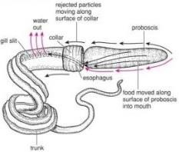

Figure 2: Feeding and digestion in enteropneusta

Lesson no. 5
Enteropneusta: Respiration, Circulation and Excretion
Because acorn worms are small, respiratory gases and metabolic waste products (principally ammonia) probably are exchanged by diffusion across the body wall. In addition, respiratory gases are exchanged at the pharyngeal slits. Cilia associated with pharyngeal slits circulate water into the mouth and out of the body through the pharyngeal slits. As water passes through the pharyngeal slits, gases are exchanged by diffusion between water and blood sinuses surrounding the pharynx. The circulatory system of acorn worms consists of one dorsal and one ventral contractile vessel. Blood moves anteriorly in the dorsal vessel and posteriorly in the ventral vessel. Branches from these vessels lead to open sinuses. All blood ﬂowing anteriorly passes into a series of blood sinuses, called the glomerulus, at the base of the proboscis. Excretory wastes may be filtered through the glomerulus, into the coelom of the proboscis, and released to the outside through one or two pores in the wall of the proboscis. The blood of acorn worms is colorless, lacks cellular elements, and distributes nutrients and wastes.

Lesson no 6
Enteropneusta: Reproduction and Development
Enteropneusts are dioecious. Two rows of gonads lie in the body wall in the anterior region of the trunk, and each gonad opens separately to the outside. Fertilization is external. Spawning by one worm induces others in the area to spawn—behavior that suggests the presence of spawning pheromones. Ciliated larvae, called tornaria, swim in the plankton for several days to a few weeks. The larvae settle to the substrate and gradually transform into the adult form (ﬁgure 3).
- Enteropneusts normally reproduce sexually via external fertilization, and develop either directly or via tornaria larvae.
- The indirect developers, including Balanoglossus and Ptychodera species, are in the majority
- These species develop from egg to planktonic tornaria larva to adult form.

- The tornaria larvae eventually become sessile, with the burrow-dwellers Developing tails behind the anus that they use to anchor themselves in their mucus-lined tunnels.
- Direct developers, on the other hand, hatch into adult animals, by passing the planktonic phase.
- An example is Saccoglossus kowalevskii.
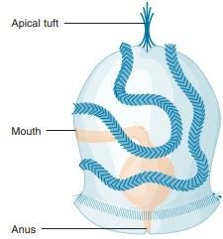
Figure 3. Tornaria Larva of an Enteropneust (Balanoglossus). When larval development is complete, a tornaria locates a suitable substrate, settles, and begins to burrow and elongate (1 mm).

Lesson no 7

Phylum Chordata
The fossil record of chordates begins in the early Cambrian period, roughly 530 million years ago. The oldest known chordate fossil was found in China and described in 1995. It is a member of the species Yunnanozoon lividium, within the subphylum Cephalochordata. The earliest fossil evidence for members of the vertebrate subphylum also dates back roughly 530 million years. This is when fossils of the jawless fish first appeared. A timeline showing the order of appearance of each of the major chordate groups in the fossil record is shown in Figure below.
The earliest tetrapods (having four legs) are the amphibians, with fossils dating back to the Devonian period, roughly 363 million years ago. Shortly thereafter, reptile-like tetrapods arose. It was some time after the appearance of reptiles, approximately 80 million years, that mammals entered the scene. The first mammalian fossils date back to the Triassic period, about 208 million years ago. Finally, bird fossils appear 146 million years ago in the Jurassic period.
Traditional metazoan phylogeny classifies the Vertebrata as a subphylum of the phylum Chordata, together with two other subphyla, the Urochordata (Tunicata) and the Cephalochordata. The Chordata, together with the phyla Echinodermata and Hemichordata, comprise a major group, the Deuterostomia. Chordates invariably possess a notochord and a dorsal neural tube. Although the origin and evolution of chordates has been studied for more than a century, few authors have intimately discussed taxonomic ranking of the three chordate groups themselves. Accumulating evidence shows that echinoderms and hemichordates form a clade (the Ambulacraria), and that within the Chordata, cephalochordates diverged first, with tunicates and vertebrates forming a sister group. Chordates share tadpole-type larvae containing a notochord and hollow nerve cord, whereas ambulacrarians have dipleurula-type larvae containing a hydrocoel. We propose that an evolutionary occurrence of tadpole-type larvae is fundamental to understanding mechanisms of chordate origin.
Although the phylum Chordata (kor-datah) (L. chorda, cord) does not have an inordinately large number of species (about 45,000), its members have been very successful at adapting to aquatic and terrestrial environments throughout the world. Sea squirts, members of the subphylum Urochordata, are brieﬂy described in the “Evolutionary Perspective” that opens this chapter. Other chordates include lancelets (subphylum Cephalochordata) and the vertebrates (subphylum Vertebrata).
Characteristics of the phylum Chordata include 1. Bilaterally symmetrical, deuterostomate animals 2. Four unique characteristics present at some stage in development: notochord, pharyngeal slits or pouches, dorsal tubular nerve cord, and postanal tail 3. Presence of an endostyle or thyroid gland 4. Complete digestive tract 5. Ventral, contractile blood vessel (heart) The four characteristics listed in number 2 are unique to chordates and are discussed further in the paragraphs that follow (ﬁgure 17.6). The phylum is named after the notochord (Gr. noton, the back
L. chorda, cord), a supportive rod that extends most of the length of the animal dorsal to the body cavity and into the tail. It consists of a connective-tissue sheath thatencloses cells, each of which contains a large, ﬂuid-ﬁlled vacuole. This arrangement gives the notochord some turgidity, which prevents compression along the anteroposterior axis. At the same time, the notochord is ﬂexible enough to allow lateral bending, as in the lateral undulations of a ﬁsh during swimming. In most adult vertebrates, cartilage or bone partly or entirely replaces the notochord. Pharyngeal slits are a series of openings in the pharyngeal region between the digestive tract and the outside of the body. In some chordates, diverticula from the gut in the pharyngeal region never break through to form an open passageway to the outside. These diverticula are then called pharyngeal pouches. The earliest chordates used the slits for ﬁlter feeding; some living chordates still use them for feeding. Other chordates have developed gills in the pharyngeal pouches for gas exchange. The pharyngeal slits of terrestrial vertebrates are mainly embryonic features and may be incomplete. The tubular nerve cord and its associated structures are largely responsible for chordate success. The nerve cord runs along the longitudinal axis of the body, just dorsal to the notochord, and usually expands anteriorly as a brain. This central nervous system is associated with the development of complex systems for sensory perception, integration, and motor responses. The fourth chordate characteristic is a postanal tail. (A postanal tail extends posteriorly beyond the anal opening.) Either the notochord or vertebral column supports the tail.
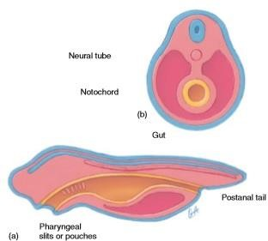
Chordate Body Plan. The development of all chordates involves the formation of a neural tube, the notochord, pharyngeal slits or pouches, and a postanal tail. Derivatives of all three primary germ layers are present. (a) Lateral view. (b) Cross section.

Lesson 8
Subphylum Urochordata

Tunicates are mainly found in the subtidal zone of a marine environment. They can be found attached to hard surfaces and are about one to twelve centimeters in length. Their color ranges from gray to brown to greenish, although some have beautiful coloration
About 2,150 species of tunicate exist in the world's oceans, living mostly in shallow water. The most numerous group is the ascidians; fewer than 100 species of these are found at depths greater than 200 m (660 ft). Some are solitary animals leading a sessile existence attached to the seabed, but others are colonial and a few are pelagic. Some are supported by a stalk, but most are attached directly to a substrate, which may be a rock, shell, coral, seaweed, mangrove root, dock, piling, or ship's hull. They are found in a range of solid or translucent colours and may resemble seeds, grapes, peaches, barrels, or bottles. One of the largest is a stalked sea tulip, Pyura pachydermatina, which can grow to be over 1 metre (3.3 ft) tall.
The Tunicata were established by Jean-Baptiste Lamarck in 1816. In 1881, Francis Maitland Balfour introduced another name for the same group, "Urochorda", to emphasize the affinity of the group to other chordates. No doubt largely because of his influence, various authors supported the term, either as such, or as the slightly older "Urochordata", but this usage is invalid because "Tunicata" has precedence, and grounds for superseding the name never existed. Accordingly, the current (formally correct) trend is to abandon the name Urochorda or Urochordata in favour of the original Tunicata, and the name Tunicata is almost invariably used in modern scientific works. It is accepted as valid by the World Register of Marine Species but not by the Integrated Taxonomic Information System.
Various common names are used for different species. Sea tulips are tunicates with colourful bodies supported on slender stalks. Sea squirts are so named because of their habit of contracting their bodies sharply and squirting out water when disturbed. Sea liver and sea pork get their names from the resemblance of their dead colonies to pieces of meat
A tunicate is a marine invertebrate animal, a member of the subphylum Tunicata. It is part of the Chordata, a phylum which includes all animals with dorsal nerve cords and notochords. The subphylum was at one time called Urochordata, and the term urochordates is still sometimes
used for these animals. They are the only chordates that have lost their myomeric segmentation, with the possible exception of the 'seriation of the gill slits'. Myomere are the blocks of skeletal muscle tissue found commonly in chordates. They are commonly zig-zag, "W" or "V"-shaped muscle fibers. The myomeres are separated from adjacent myomere by connective tissues and most easily seen in larval fishes or in the olm. Myomere counts are sometimes used for identifying specimens, since their number corresponds to the number of vertebrae in the adults.
Urochordates have a sparse fossil record. A Precambrian fossil known as Yarnemia has been referred to the Urochordata, but this assignment is doubtful. Complete body fossils of tunicates are rare, but tunicates in some families generate microscopic spicules that may be preserved as microfossils. Such spicules have occasionally been described from Jurassic and later rocks. Few paleontologists are familiar with them; tunicate spicules may be mistaken for sponge spicules.
The subphylum Urochordata constitutes a unique group of animals under the, Phylum Chordata. The members of this subphylum exhibit a high degree of diversity in form, habit and habitat.
The adults are mostly degenerated and un-segmented.

Lesson 9
Introduction to tunicates and their body organization
Members of the subphylum Urochordata (uro-kor-dahtah) (Gr. uro, tail
L. chorda, cord) are the tunicates or sea squirts. The ascidians comprise the largest class of tunicates (see table 17.1). They are sessile as adults and are either solitary or colonial.
The appendicularians and thaliaceans are planktonic as adults (ﬁgure 17.7). In some localities, tunicates occur in large enough numbers to be considered a dominant life-form. Sessile urochordates attach their saclike bodies to rocks, pilings, ship hulls, and other solid substrates. The unattached end of urochordates contains two siphons that permit seawater to circulate through the body. One siphon is the oral siphon, which is the inlet for water circulating through the body and is usually directly opposite the attached end of the ascidian (ﬁgure 17.8). It also serves as the mouth opening. The second siphon, the atrial siphon, is the opening for excurrent water. The body wall of most tunicates (L. tunicatus, to wear a tunic or gown) is a connective-tissue-like covering, called
the tunic, that appears gel-like but is often quite tough. Secreted by the epidermis, it is composed of proteins, various salts, and cellulose. Some mesodermally derived tissues, including blood vessels and blood cells, are incorporated into the tunic. Rootlike extensions of the tunic, called stolons, help anchor a tunicate to the substrate and may connect individuals of a colony.
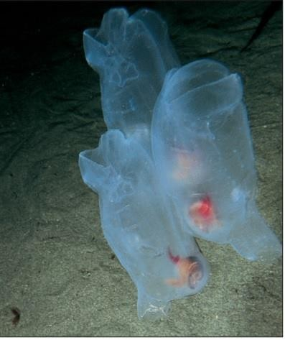
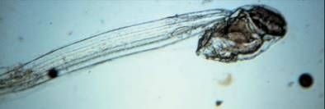
FIGURE 17.7 Subphylum Urochordata. (a) Members of the class Appendicularia are planktonic and have a tail and notochord that persist into the adult stage. (b) The thaliaceans are barrel- shaped, planktonic urochordates. Oral and atrial siphons are at opposite ends of the body, and muscles of the body wall contract to create a form of weak jet propulsion.

Tunicates: Body organization

The urochordates or tunicates are a remarkable group of organisms and typically very beautiful and photogenic.
Tunicates derive their name from a thick extracellular body covering, called a tunic that is made up of cellulose-like, complex sugars. Another interesting feature of tunicates is their circulatory

system. Instead of blood vessels, the heart pumps blood through a number of small pockets called sinuses. In addition, the heart periodically changes the direction that it pumps blood.
The adult tunicate body is shaped like a small barrel with two large openings called siphons. The inhalent siphon brings water into a saclike, central cavity, called the atrial cavity (distinct from the coelom), and then through the pharyngeal slits where food is filtered into the digestive system. The water then exits the cavity through an exhalent siphon. The tunicate coelom is reduced to a small compartment surrounding the heart. The majority of the organs lie within a body cavity below the atrial cavity called the epicardium, or visceral cavity. The visceral cavity contains the digestive tract (except for the pharynx, which is situated in the atrial cavity), the heart, and the reproductive organs. The organization of the tunicate body is shown in Figure below.
Longitudinal and circular muscles below the body wall epithelium help to change the shape of the adult tunicate. They act against the elasticity of the tunic and the hydrostatic skeleton that seawater conﬁned to internal chambers creates. The nervous system of tunicates is largely conﬁned to the body wall. It forms a nerve plexus with a single ganglion located on the wall of the pharynx between the oral and atrial openings (ﬁgure 17.9a). This ganglion is not vital for coordinating bodily functions. Tunicates are sensitive to many kinds of mechanical and chemical stimuli, and receptors for these senses are distributed over the body wall, especially around the siphons. There are no complex sensory organs.
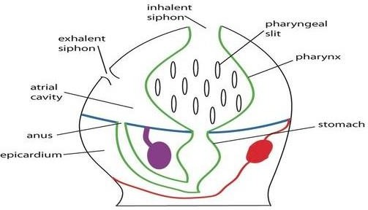

The organization of an adult tunicate body. The digestive system is outlined in green, the gonad is in purple, and the circulatory system is in red. Water is brought into the pharynx within the atrial cavity and through the pharyngeal slits via the inhalent siphon. Food particles captured by the pharyngeal slits are then passed into the remainder of the digestive system, situated in the lower cavity called the epicardium. The digestive system ends with an anus that opens back into the atrial cavity, and waste exits the body through the exhalent siphon.

Lesson no10

Tunicates: Digestion and Respiration
Most of the larger species of ascidians are solitary and made up of only one zooid, while the compound species are colonial and are composed of many zooids. Some colonies may reach sizes of one meter or more. The simplest colonies of zooids are spaced apart and connected by stolons. In most of the colonies that are comprised of specialized zooids, the zooids are completely imbedded in the tunic (Barnes and Ruppert, 1994).

Within the tunic each zooid is divided up into three regions: the thoracic (anterior), abdominal, and postabdominal. The thoracic region contains the pharynx and the abdominal contains the digestive tract. The postabdominal region is the most bottom part of the tunicate body and contains the heart and reproductive organs. Most do not have a postabdomen and some of the larger species do not have an abdomen, in this case all of the organs they would contain will be shifted up to one side of the pharynx (Barnes and Ruppert, 1994).

Tunicates mainly eat phytoplankton, zooplankton, detritus and other small organisms in the water, these organisms are filtered through the tunicate. They have cilia in the pharynx and they also produce mucus. Their food gets stuck in the mucus and with the help of beating cilia the mucus moves toward the digestive system. There are also predatory tunicates, which eat small creatures that get pulled through their siphon and get stuck on their mucous.
The most obvious internal structures of the urochordates are a very large pharynx and a cavity, called the atrium, that surrounds the pharynx laterally and dorsally (ﬁgure 17.9b). The pharynx of tunicates originates at the oral siphon and is continuous with the remainder of the digestive tract. The oral margin of the pharynx has tentacles that prevent large objects from entering the pharynx. Numerous pharyngeal slits called stigmas perforate the pharynx. Cilia associated with the stigmas
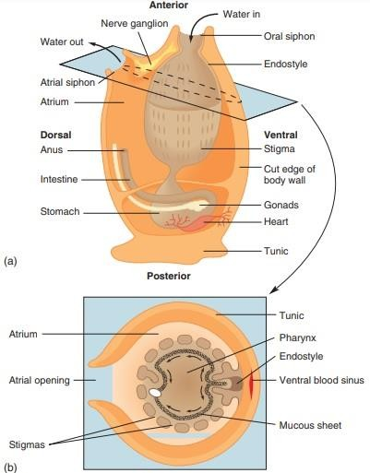
cause water to circulate into the pharynx, through the stigmas, and into the surrounding atrium. Water leaves the tunicate through the atrial siphon. The digestive tract of adult tunicates continues from the pharynx and ends at the anus near the atrial siphon. During feeding, cells of a ventral, ciliated groove, called the endostyle,form a mucous sheath (ﬁgure 17.9b). Cilia move the mucous sheet dorsally across the pharynx. Food particles, brought into the oral siphon with incurrent water, are trapped in the mucous sheet and passed dorsally. Food is incorporated into a string of mucus that ciliary action moves into the next region of the gut tract. Digestive enzymes are secreted in the stomach, and most absorption occurs across the walls of the intestine. Excurrent water carries digestive wastes from the anus out of the atrial siphon. In addition to its role in feeding, the pharynx also functions in gas exchange. Gases are exchanged as water circulates through the tunicate.
FIGURE 17.9 Internal Structure of a Tunicate. (a) Longitudinal section. Black arrows show the path of water. (b) Cross section at the level of the atrial siphon. Small black arrows show movement of food trapped in mucus that the endostyle produces.

Lesson 11

Tunicates: Circulation and Excretion
The ascidian tunicate Corella inflata is relatively transparent compared to other solitary tunicates and the circulatory system can be visualized by injecting high molecular weight fluorescein labeled dextran into the beating heart or the large vessels at the ends of the heart. In addition, after staining with neutral red the movement of blood cells can be followed to further define and characterize the circulatory system. The heart is a gently curved tube with a constriction in the middle and extends across the width of the animal. As in other tunicates, pumping is peristaltic and periodically reverses direction. During the abvisceral directional phase blood leaves the anterior end of the heart in two asymmetric vessels that connect to the two sides of the branchial basket (or pharynx), in contrast to the direct connection between the heart and the endostyle seen in the commonly studied tunicate Ciona intestinalis. In Corella inflata blood then flows in both transverse directions through a complex system of ducts in the branchial basket into large ventral and dorsal vessels and then to the visceral organs in the posterior of the animal. During the advisceral phase blood leaves the posterior end of the heart in vessels that repeatedly bifurcate to fan into the stomach and gonads. Blood speed, determined by following individual cells, is high and pulsatory near the heart, but decreases and becomes more constant in peripheral regions. Estimated blood flow volume during one directional phase is greater than the total volume of the animal. Circulating blood cells are confined to vessels or ducts in the visible parts of the animal and retention of high molecular weight dextran in the vessels is comparable to that seen in vertebrates. These flow patterns are consistent with a closed circulatory network.
The tunicate heart lies at the base of the pharynx. One vessel from the heart runs anteriorly under the endostyle, and another runs posteriorly to the digestive organs and gonads. Blood ﬂow through the heart is not unidirectional. Peristaltic contractions of the heart may propel blood in one direction for a few beats; then the direction is reversed. The signiﬁcance of this reversal is not understood. Tunicate blood plasma is colorless and contains various kinds of amoeboid cells.
The body is enclosed in a more-or-less translucent tunic. No special excretory organs appear to be present. Nitrogenous waste is excreted as ammonia, which can easily be carried away in the exhalant flow of water and by diffusion from the general body surface.

Ammonia diffuses into water that passes through the pharynx and is excreted. In addition, amoeboid cells of the circulatory system accumulate uric acid and sequester it in the intestinal loop. Pyloric glands on the outside of the intestine are also thought to have excretory functions.
One clue that tunicates are related to vertebrates is found in the tunicate larva, or tadpole. It even looks like a tiny tadpole, and has a nerve cord down its back, similar to the nerve cord found inside the vertebrae of all vertebrates.

The tail also has a semi-rigid rod called a notochord, which can be compared to the spine of true vertebrates.
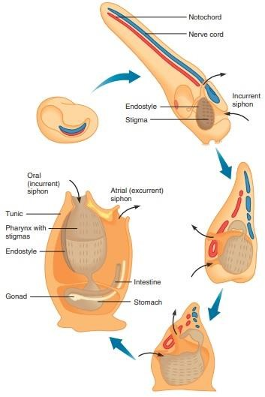
Urochordates are monoecious. Gonads are located near the loop of the intestine, and genital ducts open near the atrial siphon. Gametes may be shed through the atrial siphon for external fertilization, or eggs may be retained in the atrium for fertilization and early development. Although self-fertilization occurs in some species, cross-fertilization is the rule. Development results in the formation of a tadpolelike larva with all four chordate characteristics. Metamorphosis begins after a brief free-swimming larval existence, during which the larva does not feed. The larva settles to a ﬁrm substrate and attaches by adhesive papillae located below the mouth. During metamorphosis, the outer epidermis shrinks and pulls the notochord and other tail structures internally for reorganization into adult tissues. The internal structures rotate 180°, positioning the oral siphon opposite the adhesive papillae and bending the digestive tract into a U shape.

Lesson 12
Subphylum Cephalochordata
Cephalochordate, also called acrania, any of more than two dozen species belonging to the subphylum Cephalochordata of the phylum Chordata. Small, fishlike marine invertebrates, they probably are the closest living relatives of the vertebrates. Cephalochordates and vertebrates have a hollow, dorsal nerve cord, pharyngeal gill slits, and a notochord. In most vertebrates, the embryonic notochord is eventually replaced by bony vertebrae or cartilaginous tissue; among cephalochordates, the notochord is retained into adulthood and is never replaced by vertebrae. There are about 20 species in two families, each with a single genus. Branchiostoma was formerly called Amphioxus, a name that is retained as an informal term. The other genus is Epigonichthys, also called Asymmetron. The genus Asymmetron is sometimes retained for some species. The cephalochordate fossil record extends back to about 525 million years ago during the early part of the Cambrian Period.

Members of the subphylum Cephalochordata (sefa-lo-kordahtah) (Gr. kephalo, head
L. chorda, cord) are called lancelets. Lancelets clearly demonstrate the four chordate characteristics, and for that reason they are often studied in introductory zoology courses. The cephalochordates consist of two genera, Branchiostoma (amphioxus) and Asymmetron, and about 45 species. They are distributed throughout the world’s oceans in shallow waters that have clean sand substrates. Cephalochordates are small (up to 5 cm long), tadpolelike animals. They are elongate, laterally ﬂattened, and nearly transparent. In spite of their streamlined shape,
cephalochordates are relatively weak swimmers and spend most of their time in a filter feeding position_partly to mostly buried with their anterior end sticking out of the sand (figure 17.10). The notochord of cephalochordates extends from the tail to the head, giving them their name. Unlike the notochord of other chordates, most of the cells are muscle cells, making the notochord somewhat contractile. Both of these characteristics are probably adaptations to burrowing. Contraction of the muscle cells increases the rigidity of the notochord by compressing the ﬂuids within, giving additional support when pushing into sandy substrates. Relaxation of these muscle cells increases ﬂexibility for swimming. Muscle cells on either side of the notochord cause undulations that propel the cephalochordate through the water. Longitudinal, ventrolateral folds of the body wall help stabilize cephalochordates during swimming, and a median dorsal fin and a caudal fin also aid in swimming. An oral hood projects from the anterior end of cephalochordates. Ciliated, fingerlike projections, called cirri, hang from the ventral aspect of the oral hood and are used in feeding. The posterior wall of the oral hood bears the mouth opening that leads to a large pharynx. Numerous pairs of pharyngeal slits perforate the pharynx and are supported by cartilaginous gill bars. Large folds of the body wall extend ventrally around the pharynx and fuse at the ventral midline of the body, creating the atrium, a chamber that surrounds the pharyngeal region of the body. It may protect the delicate, ﬁltering surfaces of the pharynx from bottom sediments. The opening from the atrium to the outside is called the atriopore.
Lesson no 13

Cephalochordates: Feeding and Digestion
Cephalochordates are ﬁlter feeders. During feeding, they are partially or mostly buried in sandy substrates with their mouths pointed upward. Cilia on the lateral surfaces of gill bars sweep water into the mouth. Water passes from the pharynx, through pharyngeal slits to the atrium, and out of the body through the atriopore. Food is initially sorted at the cirri. Larger materials catch on cilia of the cirri. As these larger particles accumulate, contractions of the cirri throw them off. Smaller, edible particles are pulled into the mouth with water and are collected by cilia on the gill bars and in mucus secreted by the endostyle. As in tunicates, the endostyle is a ciliated groove that extends longitudinally along the midventral aspect of the pharynx. Cilia move food and mucus dorsally, forming a food cord to the gut. A ring of cilia rotates the food cord, dislodging food. Digestion is both extracellular and intracellular. A diverticulum off the gut, called the midgut cecum, extends anteriorly. It ends blindly along the right side of the pharynx and secretes digestive enzymes. An anus is on the left side of the ventral ﬁn.

Lesson no 14
Cephalochordates: Circulation, Excretion, Reproduction and Development Cephalochordates do not possess a true heart. Contractile waves in the walls of major vessels propel blood. Blood contains amoeboid cells and bathes tissues in open spaces. Excretory tubules are modiﬁed coelomic cells closely associated with blood vessels. This arrangement suggests active transport of materials between the blood and excretory tubules. The coelom of cephalochordates is reduced, compared to that of most other chordates. It is restricted to canals near the gill bars, the endostyle, and the gonads.
The cephalochordates constitute the smallest chordate subphyla and comprise 35 species belonging to three genera: Branchiostoma, Epigonichthys and Asymmetron. Most lanceolates are gonochorics; however, anomalous occurrence of simultaneous hermaphroditic amphioxus species is reported. In gonochorics, sex ratio is male-biased, as in Branchiostomma lanceolatum. The two series of symmetric gonads are located ventrolaterally in Branchiostoma but Asymmetron develops gonads on only the right side of the body. The larvae are asymmetrical with the mouth on the left side and gills on the right side. On metamorphosis, bilateral symmetry
is restored. Captive culture from egg to egg stage has been achieved only in B. belcheri. In temperate lanceolates, life span ranges from 2-3 years in B. floridae and B. belcheri to 8 years in B. Lanceolatu.
Cephalochordates are dioecious. Gonads bulge into the atrium from the lateral body wall. Gametes are shed into the atrium and leave the body through the atriopore. External fertilization leads to a bilaterally symmetrical larva. Larvae are free-swimming, but they eventually settle to the substrate before metamorphosing into adults.

LESSON NO 15

Phylogenetic Relationships between hemichordates and chordates
Animals in the phyla Hemichordata and Chordata share deuterostome characteristics with echinoderms (ﬁgure 17.2). Most zoologists, therefore, believe that ancestral representatives of these phyla were derived from a common, as yet undiscovered, triploblastic ancestor. The chordates are characterized by a dorsal tubular nerve cord, a notochord, pharyngeal slits or pouches, and a postanal tail. The only characteristics they share with the hemichordates are pharyngeal slits and, in some species, a dorsal tubular nerve cord. Therefore, most zoologists agree that the evolutionary ties between the chordates and hemichordates are closer than those between echinoderms and either phylum. Chordates and hemichordates, however, probably diverged from widely separated points along the deuterostome lineage. The diverse body forms and lifestyles present in these phyla support this generalization.
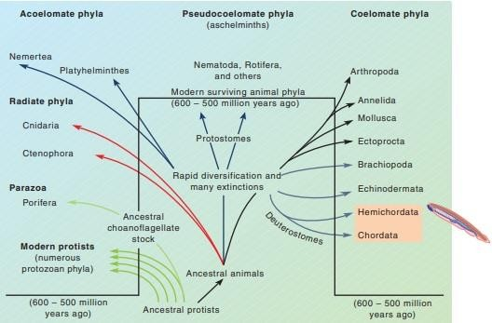
FIGURE 17.2 Phylogenetic Relationships among the Hemichordata and Chordata. Hemichordates and chordates (shaded in orange) are distantly related deuterostomes derived from a common, as yet undiscovered, diploblastic or triploblastic ancestor.

LESSON NO16

Deuterostomate Phylogeny
The evolutionary relationships between the hemichordates and chordates are difﬁcult to document with certainty. The dorsal tubular nerve cord and pharyngeal slits of hemichordates are evidence of evolutionary ties between these phyla (ﬁgure 17.11). Questions regarding the homologies of these structures, however, remain. Synapomorphies that distinguish chordates from hemichordates include tadpole larvae, a notochord, a postanal tail, and an endostyle. Figure 17.11 also shows evolutionary relationships between members of the three chordate subphyla. As discussed in chapter 16, the earliest echinoderms were probably sessile ﬁlter feeders. The lifestyle of adult urochordates suggests a similar ancestry (perhaps from a common ancestor with echinoderms) for chordates. The evolution of motile chordates from attached ancestors may have involved the development of a tadpolelike larva. Increased larval mobility is often adaptive for species with sedentary adults because it promotes dispersal. The evolution of motile adults could have resulted from paedomorphosis, which is the development of sexual maturity in the larval body form. (Paedomorphosis is well documented in the animal kingdom, especially among amphibians.) Paedomorphosis could have led to a small, sexually reproducing, ﬁshlike chordate that could have been the ancestor of higher chordates. The largest and most successful chordates belong to the subphylum Vertebrata. Bony or cartilaginous vertebrae that completely or partially replace the notochord characterize the vertebrates. The development of the anterior end of the nerve cord into a brain and the development of specialized sense organs on the head are evidence of a high degree of cephalization. The skeleton is modiﬁed anteriorly into a skull or cranium. There are eight classes of vertebrates (see table 17.1).Because of their cartilaginous and bony endoskeletons, vertebrates have left an abundant fossil record. Ancient jawless ﬁshes were common in the Ordovician period, approximately 500 million years ago. Over a period of approximately 100 million years, fishes became the dominant vertebrates. Near the end of the Devonian period, approximately 400 million
years ago, terrestrial vertebrates made their appearance. Since that time, vertebrates have radiated into most of the earth’s habitats. Chapters 18 through 22 give an account of these events.

